List of Experiments(Examples)

Suggested domains for Mini-project.
1. Passport automation system.
2. Library Management
3. Exam registration
4. Stock maintenance system.
5. Online course learning system
6. Airline/Railway reservation system
7. Software personnel management system
8. E-commerce
9. e-book management system
10. Recruitment system
11. Banking System
12. Conference management system
13. Attendance management system
14. Restaurant management system
15. Student Information system
16. Admission system
17.Ai chat board
18. Inventory management system
19. Hospital management
20. Grocery management
21.Fitness (gym) system
22.School management system
23.OLX
24.Quiz app
25.Spotify (music app)
26.home service(plumber,electrician erc)
27.Online property management
28.Travelling app

EX NO: 7 AIRLINE/RAILWAY RESERVATION SYSTEM
Date:
AIM
To develop the Airline/Railway reservation System using Rational Rose Software.
(I) PROBLEM ANALYSIS AND PROJECT PLANNING
In the Airline/Railway reservation System the main process is a applicant have to login the database then the database verifies that particular username and password then the user must fill the details about their personal details then selecting the flight and the database books the ticket then send it to the applicant then searching the flight or else cancelling the process.
(II) OVERALL DESCRIPTION
2.1 Functionality
The database should be act as an main role of the e-ticketing system it can be booking the ticket in easy way.
2.2 Usability
The User interface makes the Credit Card Processing System to be efficient.
2.3 Performance
It is of the capacities about which it can perform function for many users
at the same times efficiently that are without any error occurrence.
2.4 Reliability
The system should be able to process the user for their corresponding request.
(III) USE CASE DIAGRAM
The passenger can view the status of the reserved tickets. So the passenger can confirm his/her travel.
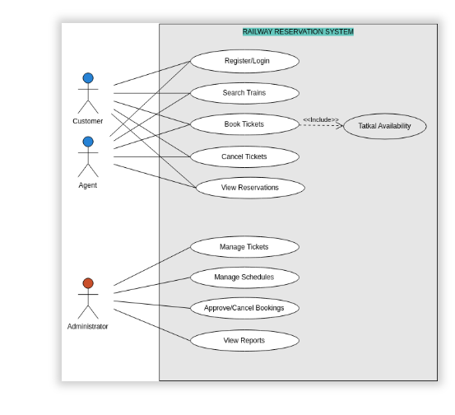
Fig. USE-CASE DIAGRAM FOR AIRLINE RESERVATION
(IV) CLASS DIAGRAM
The online ticket reservation system makes use of the following classes:
1. ticketReservation
2. trainInfo
3. passengerInfo
4. seatAvailStatus
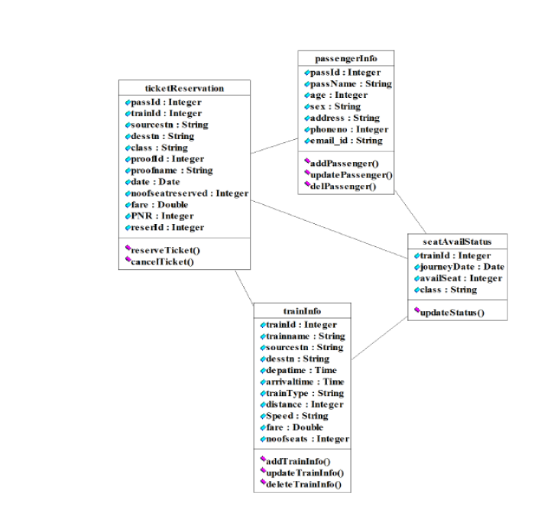
SEQUENCE DIAGRAM
A sequence diagram in Unified Modeling Language (UML) is a kind of interaction diagram that shows how processes operate with one another and in what order. It is a construct of a Message Sequence Chart. There are two dimensions.
1. Vertical dimension-represent time.
2. Horizontal dimension-represent different objects.
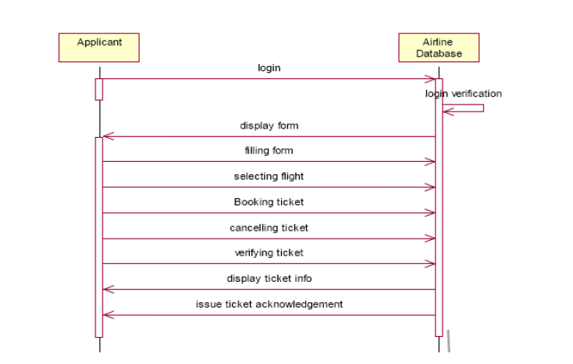
COLLABRATION DIAGRAM
A collaboration diagram, also called a communication diagram or interaction diagram,. A sophisticated modeling tool can easily convert a collaboration diagram into a sequence diagram and the vice versa. A collaboration diagram resembles a flowchart that portrays the roles, functionality and behavior of individual objects as well as the overall operation of the system in real time.

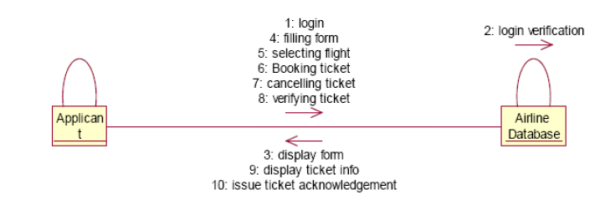

STATE CHART DIAGRAM
The purpose of state chart diagram is to understand the algorithm involved in performing a method. It is also called as state diagram. A state is
represented as a round box, which may contain one or more compartments. An initial state is represented as small dot. A final state is represented as circle surrounding a small dot. 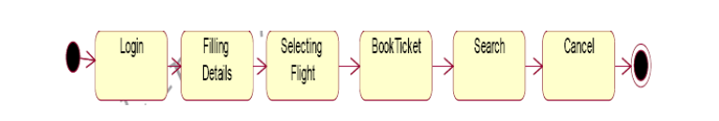ACTIVITY DIAGRAM
Activity diagrams are graphical representations of workflows of stepwise activities and actions with support for choice, iteration and concurrency. In the Unified Modeling Language, activity diagrams can be used to describe the business and operational step-by-step workflows of components in a system. An activity diagram shows the overall flow of control. An activity is shown as an rounded box containing the name of the operation.
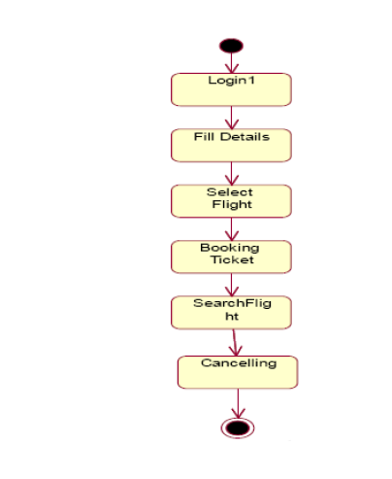
COMPONENT DIAGRAM
The component diagram's main purpose is to show the structural relationships between the components of a system. It is represented by boxed figure. Dependencies are represented by communication association.

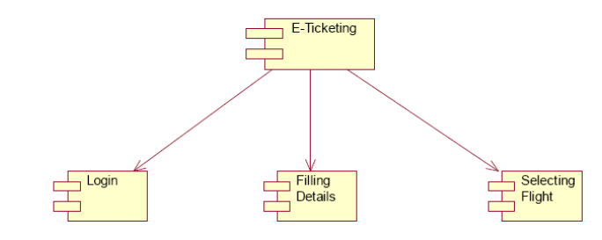

RESULT
Thus the mini project for Airline/Railway reservation System has been successfully executed and codes are generated.

